**Component Selections**

In our simulations, we tried to observe the critical limits of our components. For the primary side diode, the voltage on it is twice of the input voltage which has a maximum value of 96 Volts. For the current limitations, the need is really small as indicated in Figure 1. Furthermore, since our working frequency is 20kHz, we searched for Schottky diodes that can switch fast. Our selection for the primary side diode is ***MUR415RL*** which is a Schottky diode with reverse voltage rating of 150 volts and current rating of 4 Amperes.

For the secondary side diodes (both secondary and freewheeling diodes), the needed voltage level is same with maximum input voltage which is 48 volts and the current level is around 5 Amperes as indicated in Figures 2 and 3. Our selection for the secondary side diodes is ***MBRF1060 C0G*** which is also a Schottky diode with reverse voltage rating of 60 volts and current rating of 10 Amperes.

For the switching device, we are going to use a MOSFET which provides the needed fast switching action for our application. For the rating of the MOSFET, the maximum voltage on it is 96 Volts and the maximum current is around 5 Amperes as indicated in the Figure 4. Our selection for switching device is ***HUF75925D3ST*** which has a voltage rating of 200 Volts and a current rating of 11 Amperes.

In the simulations, we observed a ripple less than 2% with a DC link capacitor of 200uF. Voltage on the capacitor is 10 Volts which is our output voltage. We searched for capacitors with low ESR value to keep the voltage ripple low and the selected capacitor is ***B41888C6227M008*** which has a capacitance of 220uF (which reduces the ripple more) and voltage rating of 50 Volts.

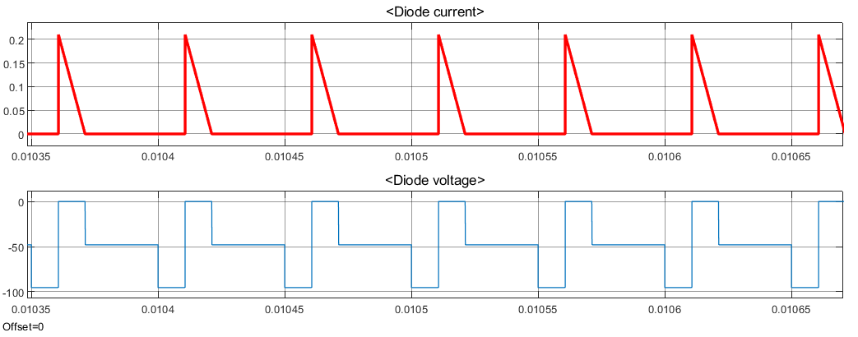

Figure : Primary side diode voltage and current characteristics for Vin=48V.

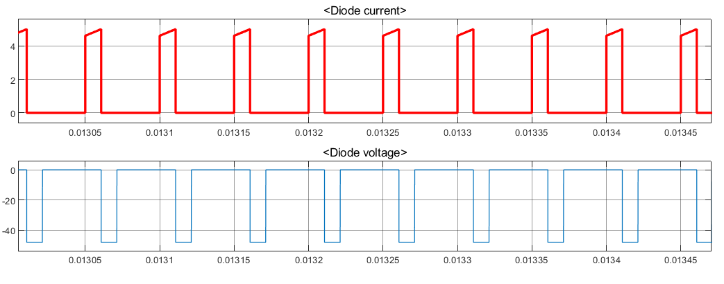

Figure : Secondary side diode voltage and current characteristics for Vin=48V.

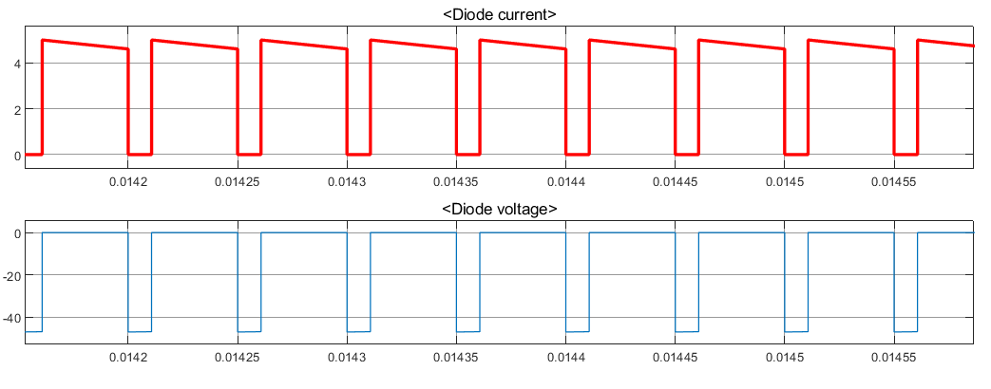

Figure : Freewheeling diode voltage and current characteristics for Vin=48V.

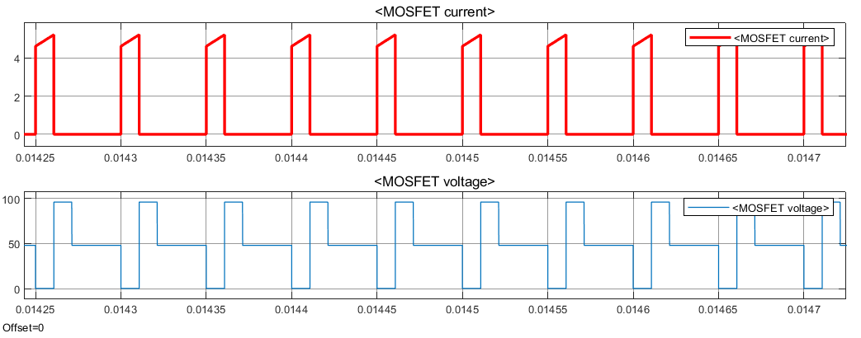

Figure : MOSFET voltage and current characteristics for Vin=48V.